*Florida International University*

*School of Computing and Information Sciences*

Software Engineering Focus

Feature Document

User Story #**107 - HMD Controller Functions**

**Team Member:**

Jacob Leschen

**Product Owner(s)**:

Francisco Ortega

**Instructor**: Masoud Sadjadi

**User Story** Implement functionality to the HTC vive’s controller set

* As a user, I would like to have multiple functions for the button scheme on the HTC Vive controller, so that I can interact with the 3D world

Acceptance Criteria

* All buttons mapped to some function
* Can pick up and manipulate objects
* Can equip and use tools with controllers (such as a gun)

**Use Case** #**1 – Teleport -** User can cast a line, then move in 3D space to the point where the line ends.

**Use Case** #**2 – Pick Up -** User can move the controller over an object, and then pick it up.

**Use Case** #**3 – Use Object -** User can interact with an object. Can be set to only use if picked up.

**Use Case Diagram**

Untitled Diagram (4).png

**Sequence Diagram**

Untitled Diagram (5).png

**Class Diagram**

Class5.png

**Unit Test**

Test case: Move user

Purpose: Test to see if user can move to intended locations

Preconditions: User has no object picked up; user has object picked up

Action: user presses the teleport button, points to a location, then releases it if the color is green

Expected result: User should move to the pointed to location if the color of the beam is green, does not if the color is red

Test case: Pick up object

Purpose: Test to see if object picks up when touched

Preconditions: User has no object in hand

Action: User moves controller over the object, then uses the pickup button

Expected result: Object should be highlighted when the models intersect, then the object should snap into place with the controller and track the movement

Test case: Use object

Purpose: Test to see if usable objects work properly

Preconditions: User has usable object picked up

Action: With usable object in hand, the user presses the use button.

Expected result: Usable object (gun) should shoot a projectile

**Visual User Guide**

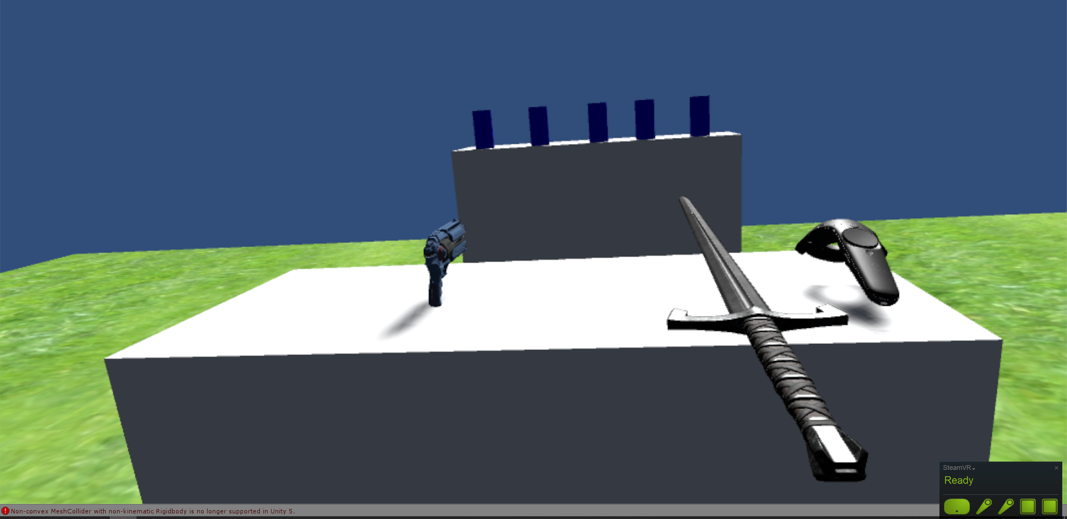

The new features - 2 tools and a test range

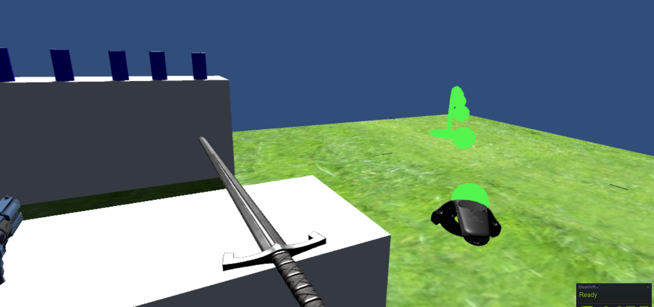Users can teleport to a location by pressing the circle-pad button, pointing with the bezier curve, and releasing the button. Inaccessible locations will be designated by a red pointer curve

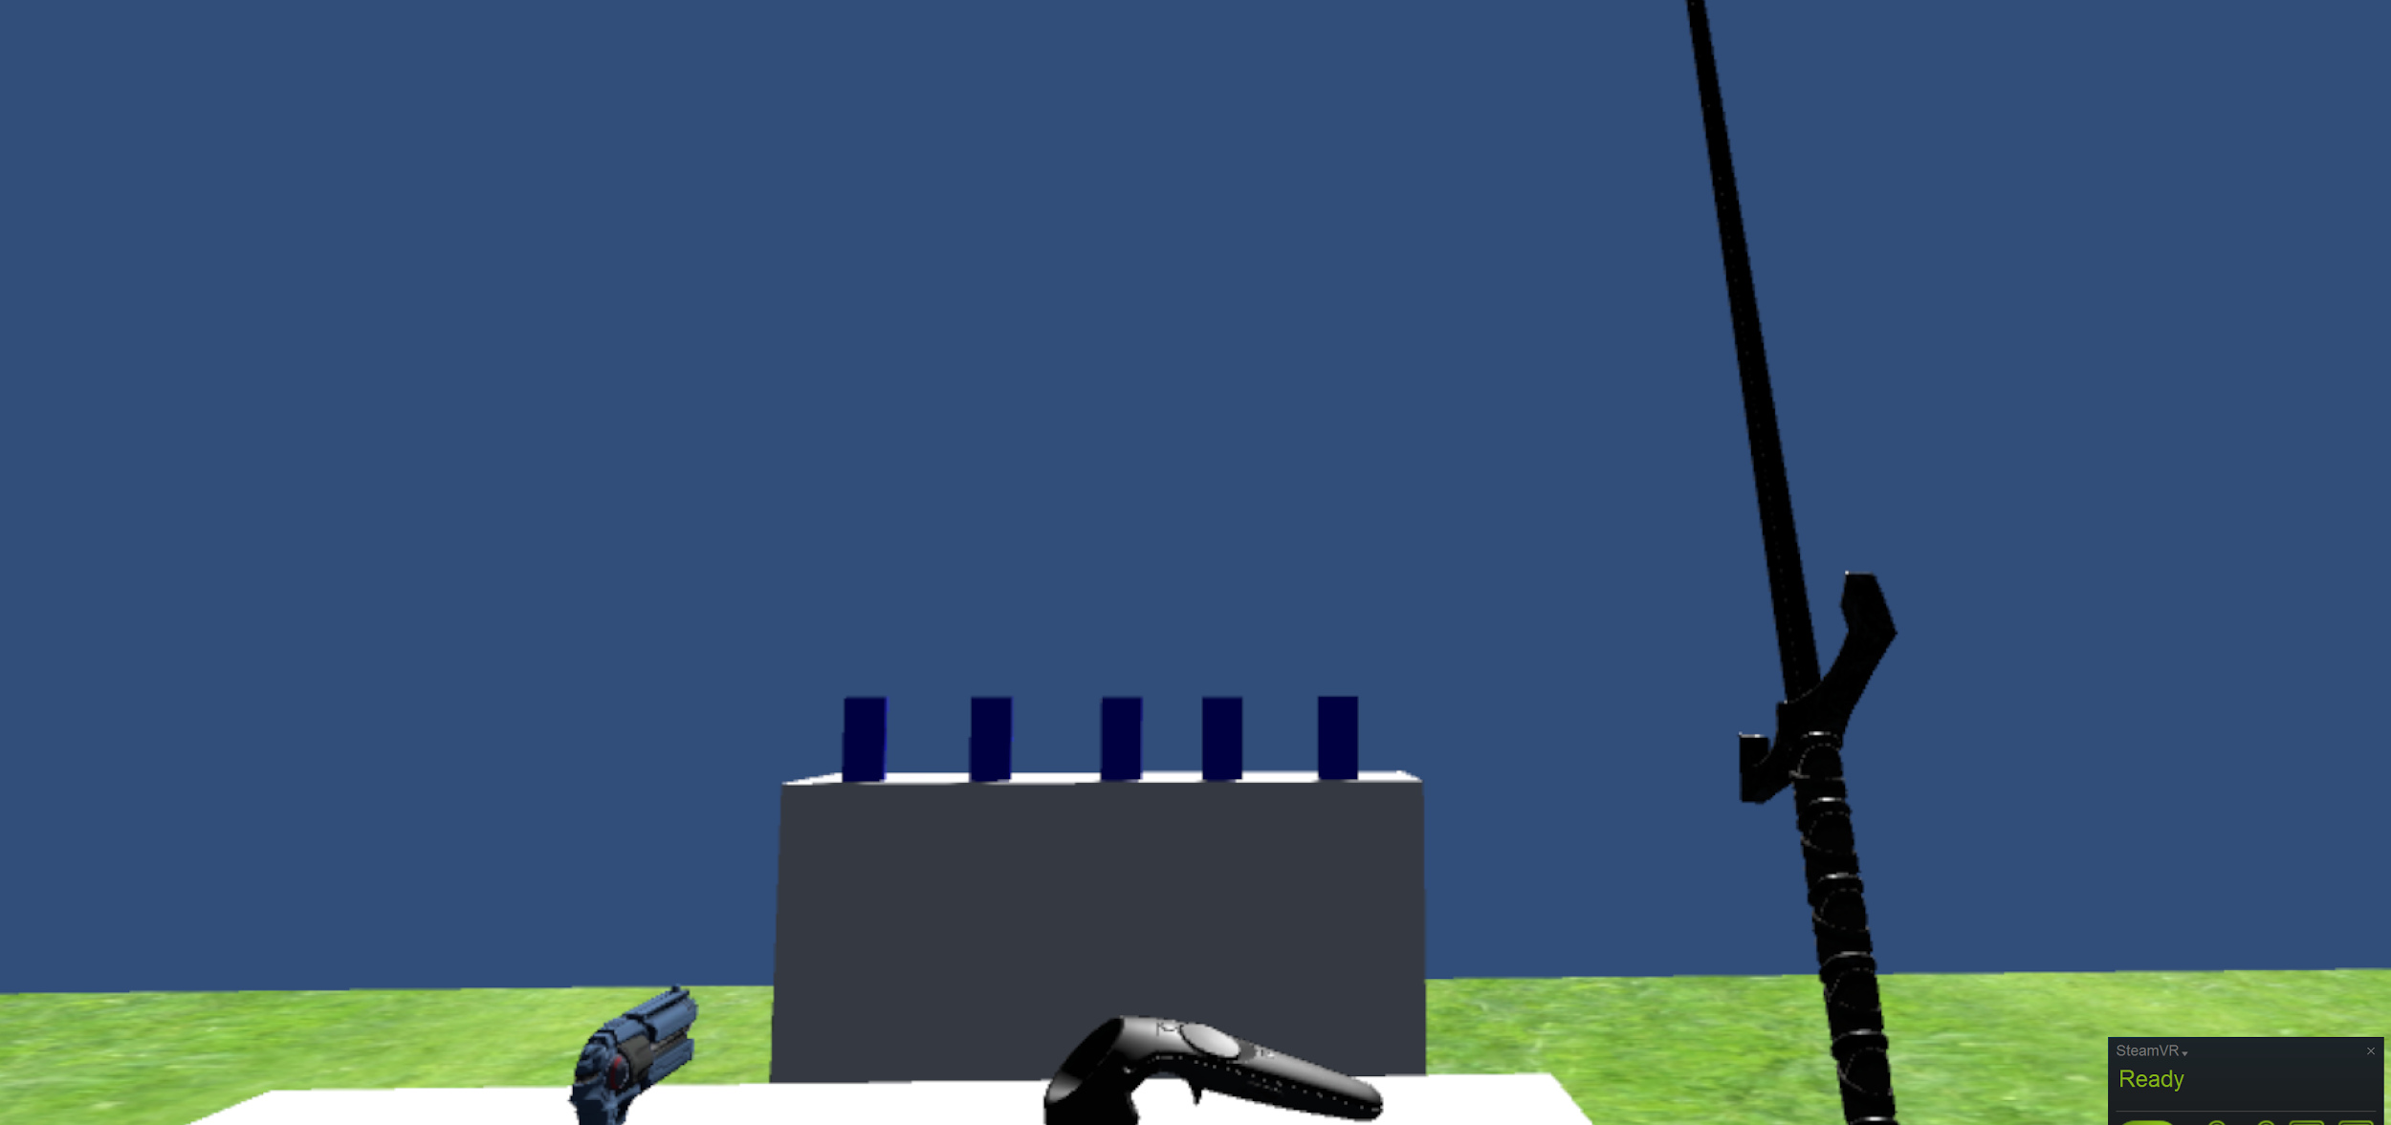

Grabbed objects can be set to replace the controller model, and snap into place depending on the intended orientation of the model. Some models can be set to pick up on a toggle and others can force the user to hold down the button to carry them

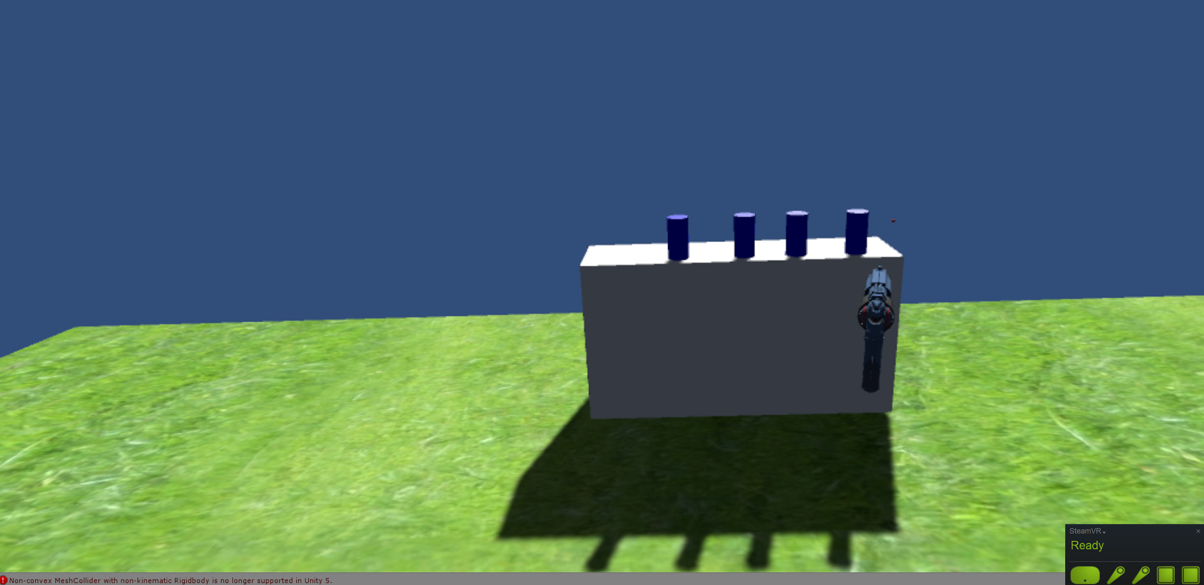

The pistol tool has functionality - after it is picked up, the user can press the trigger button on the controller to fire a bullet that has it’s own velocity and weight. The user can try to knock down the cans across the field.